Unit 3: Terminal Velocity

**Course-wide Learning Goals:**

By the end of the three-course intro lab sequence, students should be able to:

1. Collect data and revise the experimental procedure iteratively, reflectively, and responsively,
2. Evaluate the process and outcomes of an experiment quantitatively and qualitatively,
3. Extend the scope of an investigation whether or not results come out as expected,
4. Communicate the process and outcomes of an experiment, and
5. Conduct an experiment collaboratively and ethically.

### Objectives:

By the end of these activities, you should be able to:

* Design, carry out, and improve an experiment to test competing physical models
* Identify, minimize, and/or quantify sources of statistical uncertainty, systematics, or mistakes
* Decide what and how much data are to be gathered to produce reliable measurements
* Describe how weighted least-squares provides a measure of the best-fit
* Plot a residual graph and calculate the chi-squared statistic to compare data to a model

**Pre-Lab Activity I (Due the day before lab section meets during the week of Sept. 25-29 at 11:59pm):**

From the data provided on LabArchives, estimate the terminal velocity of the coffee filter (i.e. after the coffee filter has been falling and accelerating, it eventually maintains a constant velocity). Fully explain all your decisions including any assumptions or approximations that you make, reasons for graphical representations that you construct, and/or calculations that you perform. Describe questions that emerge and the decisions you made to address those questions as you determined the terminal velocity. For example, which data points did you include and exclude, and why? How might you come up with a measure of uncertainty in your terminal velocity estimate?

**Pre-Lab Activity II (Due the day before lab section meets during the week of Oct. 2-6 at 11:59pm):**

Use the data provided on LabArchives to compare the consistency of the data with one of the models (either $v∝\sqrt{m}$ or $v∝m$). Produce a graphical representation **and** a quantitative value ($χ^{2}$) that compares the data with one of the models. Discuss how well the model fits the data. Describe how you will improve your own data this week.

Warm Ups Day 1 (5 minutes):

Lead an open-ended whole class discussion about questions that students have as a result of the prelab activity. Possible points of discussion that will be relevant to this lab might include:

* + What methods did you develop for finding the terminal velocity? Calculations? Graphs?
  + What are the affordances of these methods? Limitations?
  + What is difficult or unexpected about determining the terminal velocity? How is this similar or different to what you have done in mathematics courses?

Students may not enter lab knowing how to account for uncertainty in the terminal velocity measurement. By the end of the lab during Week 1, all students need to know how to do this so incorporate this discussion at the beginning and then lead a follow-up discussion after students have collect some of their own data. It is very important that students leave the lab knowing how to determine the terminal velocity, so maintain a fast pace through the invention activity to get to data collection for the second half of the lab.

Develop an Excel template that can be used for this week’s part of the lab to automatically calculate $χ^{2}$ when inputting new data. The weighted least squares regression tutorial provides a step-by-step outline of one possible way to set-up a spreadsheet. The graphing tutorial will be helpful for producing a graphical representation.

Instructor notes (Transition to Models):

Summarize (briefly) that terminal velocity arises when gravitational forces balance the air resistance/lift forces. Then present two possible models: terminal velocity is either proportional to mass or proportional to sqrt(mass). Do not spend time explaining when these models are typically appropriate. Students can learn about these outside of lab time – some instructors will introduce the models in other parts of the course. Write the models on the whiteboard.

|  |
| --- |
| **Activity I: Test the Models** |

1. **Design an experiment to test models**

Based on the discussion about the two competing models that characterize the terminal velocity of the falling coffee filters, design an experiment to test which model best characterizes the motion of the coffee filters. In your design consider:

* What are the relevant variables to control and which ones do you need to explore?
* What are some logistical issues associated with the data collection that may cause unnecessary variability (either statistical or systematic) or mistakes? How can you control or measure these?
* What ways can you graph your data and which ones will help you figure out which model better describes your data?

Discuss your design with other groups and modify as you see fit. Record all your decisions as you develop your design.

**Week 1 Instructor Time Stamp: After 45 minutes of allowing students to collect data and determine the terminal velocity with uncertainty, students should be ready for a conversation about quantitative and qualitative ways to determine whether data is consistent with a model since their statistical toolbox from Pendulum for Pros and Collisions comes up short. At this time Activity II must be completed before students can return to Activity I. for the remainder of the two week lab.**

1. **Run the experiment and improve design**

As you perform your trials, consider the following: Do your graphs provide evidence of which model is best? What ways can you improve your methods, data, or graphs to make your case more convincing? Do you need to change how you’re collecting data? Do you need to take data in different regions? Do you just need more data? Do you need to reduce the uncertainty? What are other groups doing/finding?

Improve your data and measurements to develop convincing evidence of the best model for the relationship between mass and terminal velocity of the falling coffee filters. In your lab notes, describe your improvement and why you made that improvement (drawing on your data collected so far). After implementing your improvement, reflect on whether it was actually an improvement. Have your data and results brought up new questions you would like to pursue?

Make sure to keep track of your progress and process as you go. As always, your final product is less important than how you get there.

Instructor notes:

If mass range is too small, the linear and quadratic models will look very similar. The most common improvement, therefore, is to extend the mass range. If mass gets too high, it gets very difficult to reach terminal velocity. Students can be creative here (standing on tables, etc.)

**Note on Excel Use:** In the first semester, all students need to use Microsoft Excel so that students who have no computational experience can gain experience with a tool that can be used for data analysis in the introductory lab sequence. Some students will enter the with little or no experience using Excel, and even those who have used Excel have probably never used Excel in this way. As students begin to take and fit data, check in with groups to ensure that all members are learning Excel and that the role is not exclusively filled by the most experienced student.

**Week 2 Instructor Time Stamp: Within the first 60 minutes of lab in Week 2, all groups must have minimized chi-squared for both models with, at least, a small dataset for three different masses. This allows them the time to improve their experiment.**

|  |
| --- |
| **Instructor Time Stamp: 65 minutes during Week 1 Activity II: Thinking about best fits** |

Your group has dropped a coffee filter and collected data for its height above the floor at different times along the fall. Your group decides that the coffee filter reaches terminal velocity just before 1 second, and one of your group members catches it after 10 seconds. Each student in your group draws fit lines, but each of your fit lines are different. In this task, we will come up with graphical and quantitative ways to determine which line is the best fit to the data.

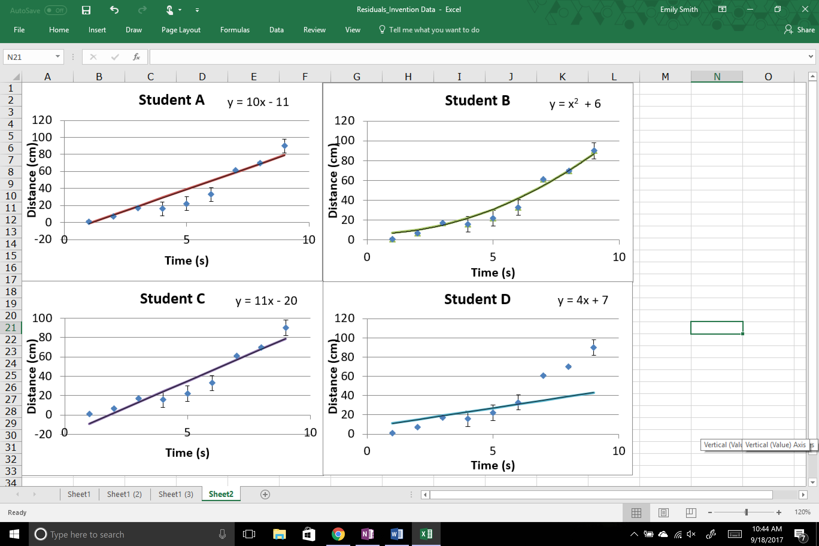

|  |  |  |
| --- | --- | --- |
| Time (s) | Distance (cm) | Uncertainty in distance (cm) |
| 1 | 1 | 1 |
| 2 | 7 | 1 |
| 3 | 17 | 1 |
| 4 | 16 | 8 |
| 5 | 22 | 8 |
| 6 | 33 | 8 |
| 7 | 61 | 1 |
| 8 | 70 | 1 |
| 9 | 90 | 8 |

**A. Intuitive Interpretation**

Which students’ lines are you most confident represent a good fit to the data? Rank the fits from the most to least confident that they represent a good fit to the data.

**B. Invent a graphically representation**

**Invent procedures to graphically represent how well the lines fit to the data**

Be creative! Sketch as many as you can think of! There are many possible ways to do this, but the same procedure must be used for each line so that a fair comparison may be made between lines. Outline your procedures and sketch the representations for at least two fit lines. Show how it helps you see how well each of the lines fit the data. Discuss the advantages and disadvantages of each of your representations as a group. We will also discuss as a class.

**C. Invent a procedure**

**Invent procedures to compute an index for each student’s best fit line to determine which student’s model is a better fit to the data**

Build general formulas for the index that can calculate a single value for each fit. The guidelines for this index are as follows:

1. Each student’s model applies to the whole data range, so each student’s line only gets a single value as their index.
2. The exact same procedure must apply to each student’s line to determine its index.
3. A smaller index implies that the model describes the data more reliably.

We will have a group discussion about everyone’s inventions. Use the data and line information provided to compute the index for each student. How do your results compare to your intuitive rankings?

Instructor Notes:

* Contrasting cases: Line D = balance points above and below the line; Line C = unweighted; Line A = weighted + good physical model; Line B = fit looks visually good + model inappropriate for physical situation
* Common issue: Some students will prefer line C to line A. Possible guiding questions: how does the uncertainty factor into things? Should we treat all points equally? Why or why not?
* Common issue: Some students will prefer line B to line A. Possible guiding questions: what is the physical situation? Should we consider the scenario when selecting a model? Why or why not?
* Graphical: This is awkward. The goal is to converge on residual plots. Features: emphasizes the differences between the points and the line more than the regular graph does. Good fit means a) residuals are small compared to the uncertainty, b) points with smaller uncertainty have proportionally smaller residuals, c) residuals are randomly distributed (no pattern).
* Equation: Common difficulty is that students don’t know how to incorporate uncertainty. They will multiply by uncertainty so that more points with small uncertainty leads to a lower index (the goal). At some point, describe why dividing by uncertainty helps (makes sure that difference is small if uncertainty is small, but difference can be a bit bigger if uncertainty is bigger).

As before, have students present their inventions. As a class, discuss the pros and cons of each (no idea is a bad idea!). Eventually settle on the “expert” solution. Goal is to get a small chi-squared.

Additional Instructor Notes:

Experimental design considerations:

* Students may struggle to orient the Sonic Ranger. Allow them time to explore and understand how the Ranger must be oriented to capture the motion of the coffee filter. After they recognize the direction that the Ranger detects motion, some students may want an explanation that the Ranger is using sound waves to capture the position.
* If you leave the experimental set up for students to design, then students will be inventive in their use of the equipment. They may place the Ranger on the floor and drop the coffee filters from high above. They may “creatively” attach the Ranger to the stand (help them understand how the clamps are intended to be used if there is a situation where equipment might break). Allow for students to design the experiment in a variety of ways. If there is time have them consider whether there are limitations to their design. For example: Does the Sonic Ranger accurately track position close to the sensor? Far from the sensor?

Ways for students to look at data:

* + If students use Excel’s best fit line, prompt them to calculate whether Excel accounts for the uncertainties in that fit. Can they improve the fit by considering the uncertainties? Hint: The fits you’ll get from doing a weighted least squares regression is slightly different than the one that Excel will give you (but the trendline is a good place to begin with a “guess”). *Especially prompt them to consider how they know one fit is better than another because Excel only gives R-squared, which is a measure of correlation and not of best fit.*
  + If students use residual graphs, prompt them to consider whether there are any trends. Are the residuals randomly arranged? How do they know what is a good fit from residual graphs?
  + If students are calculating the weighted least squares parameter, prompt them to consider how to appropriately guess fitting parameters from the physical situation. How is a fit estimated? What do you know about the situation? How do you know when you’ve minimized the parameter?
  + If students do not have uncertainty associated with their terminal velocities, ask them to consider how they might determine the uncertainty.
  + Where should the fit pass through the origin?
  + Is there a way to linearize the square relationship?
  + How does LoggerPro calculate velocity? (See https://www.vernier.com/til/1011/)
  + Are there limitations to the equipment? (Does the Sonic Ranger accurately capture position both close to and far from the speaker?)
  + Either a one or two parameter fit can be used, but students should justify their choice (physics and statistics). Some instructors have posed the question of the terminal velocity of a helium balloon at different inflations to motivate two parameter fits.